**HTML ATTRIBUTE**

We have seen few HTML tags and their usage like heading tags **<h1>, <h2>,** paragraph tag **<p>** and other tags. We used them so far in their simplest form, but most of the HTML tagscan also have attributes, which are extra bits of information.

An attribute is used to define the characteristics of an HTML element and is placed inside the element's opening tag. All attributes are made up of two parts: a **name** and a **value**:

* The **name** is the property you want to set. For example, the paragraph **<p>** element in the example carries an attribute whose name is **align**, which you can use to indicate

the alignment of paragraph on the page.

•

* The **value** is what you want the value of the property to be set and always put within quotations. The below example shows three possible values of align attribute: **left, center** and **right**.

Attribute names and attribute values are case-insensitive. However, the World Wide Web Consortium (W3C) recommends lowercase attributes/attribute values in their HTML 4 recommendation.

**Example**



<!DOCTYPE html>

<html>

<head>

<title>Align Attribute Example</title>

</head>

<body>

<p align="left">This is left aligned</p>

<p align="center">This is center aligned</p>

<p align="right">This is right aligned</p>

</body>

</html>

This will display the following result:



This is left aligned

This is center aligned

27



HTML

This is right aligned

**Core Attributes**



The four core attributes that can be used on the majority of HTML elements (although not all)

are:

* Id
* Title
* Class
* Style

**The Id Attribute**

The **id** attribute of an HTML tag can be used to uniquely identify any element within an HTML page. There are two primary reasons that you might want to use an id attribute on an element:

* If an element carries an id attribute as a unique identifier, it is possible to identify just that element and its content.
* If you have two elements of the same name within a Web page (or style sheet), you can use the id attribute to distinguish between elements that have the same name.

We will discuss style sheet in separate tutorial. For now, let's use the id attribute to distinguish between two paragraph elements as shown below.

**Example**



<p id="html">This para explains what is HTML</p>

<p id="css">This para explains what is Cascading Style Sheet</p>

**The title Attribute**

The **title** attribute gives a suggested title for the element. They syntax for the **title** attribute is similar as explained for **id** attribute:

The behavior of this attribute will depend upon the element that carries it, although it is often displayed as a tooltip when cursor comes over the element or while the element is loading.

**Example**

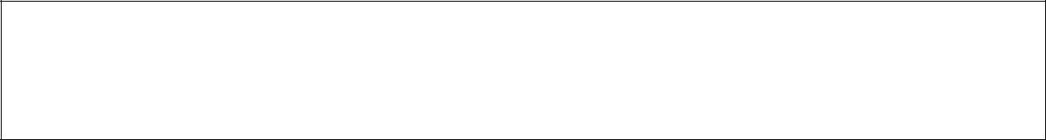

<!DOCTYPE html>

<html>

<head>

28



HTML



<title>The title Attribute Example</title>

</head>

<body>

<h3 title="Hello HTML!">Titled Heading Tag Example</h3>

</body>

</html>

This will produce the following result:



**Titled Heading Tag Example**

Now try to bring your cursor over "Titled Heading Tag Example" and you will see that whatever title you used in your code is coming out as a tooltip of the cursor.

**The class Attribute**

The **class** attribute is used to associate an element with a style sheet, and specifies the class of element. You will learn more about the use of the class attribute when you will learn Cascading Style Sheet (CSS). So for now you can avoid it.

The value of the attribute may also be a space-separated list of class names. For example:



class="className1 className2 className3"

**The style Attribute**

The style attribute allows you to specify Cascading Style Sheet (CSS) rules within the element.



<!DOCTYPE html>

<html>

<head>

<title>The style Attribute</title>

</head>

<body>

<p style="font-family:arial; color:#FF0000;">Some text...</p>

</body>

</html>

This will produce the following result:

29



HTML



Some text...

At this point of time, we are not learning CSS, so just let's proceed without bothering much about CSS. Here, you need to understand what are HTML attributes and how they can be used while formatting content.

**Internationalization Attributes**



There are three internationalization attributes, which are available for most (although not all) XHTML elements.

* dir
* lang
* xml:lang

**The dir Attribute**

The **dir** attribute allows you to indicate to the browser about the direction in which the text should flow. The dir attribute can take one of two values, as you can see in the table that follows:

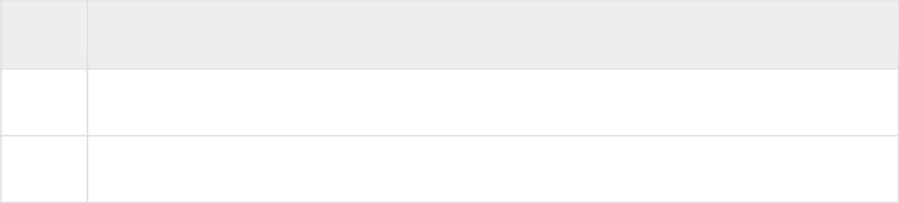

**Value**

**Meaning**

ltr

Left to right (the default value)

rtl

Right to left (for languages such as Hebrew or Arabic that are read right to left)

**Example**



<!DOCTYPE html>

<html dir="rtl">

<head>

<title>Display Directions</title>

</head>

<body>

This is how IE 5 renders right-to-left directed text.

</body>

</html>

This will produce the following result:

30



HTML



This is how IE 5 renders right-to-left directed text.

When *dir* attribute is used within the <html> tag, it determines how text will be presented within the entire document. When used within another tag, it controls the text's direction for just the content of that tag.

**The lang Attribute**

The **lang** attribute allows you to indicate the main language used in a document, but this attribute was kept in HTML only for backwards compatibility with earlier versions of HTML. This attribute has been replaced by the **xml:lang** attribute in new XHTML documents.

The values of the *lang* attribute are ISO-639 standard two-character language codes. Check [**HTML Language Codes: ISO 639**](http://www.tutorialspoint.com/html/language_iso_codes.htm) for a complete list of language codes.

**Example**



<!DOCTYPE html>

<html lang="en">

<head>

<title>English Language Page</title>

</head>

<body>

This page is using English Language

</body>

</html>

**The xml:lang Attribute**



The *xml:lang* attribute is the XHTML replacement for the *lang* attribute. The value of the*xml:lang* attribute should be an ISO-639 country code as mentioned in previous section.

**Generic Attributes**

Here's a table of some other attributes that are readily usable with many of the HTML tags.

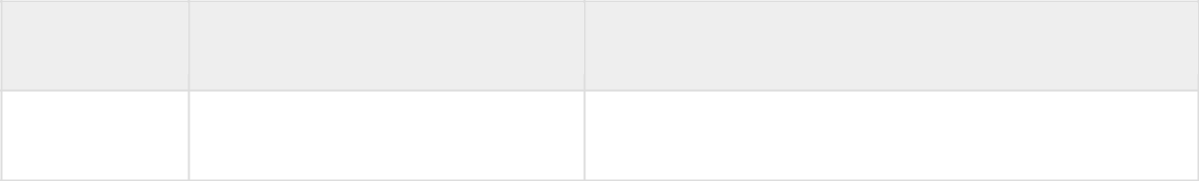

**Attribute**

**Options**

**Function**

align

right, left, center

Horizontally aligns tags

31



|  |  |  |  |  |  |
| --- | --- | --- | --- | --- | --- |
|  | |  | | HTML | |
|  |  | |  | |  |
| valign | top, middle, bottom | | Vertically aligns tags within an HTML | |  |
|  |  | | element. | |  |
|  |  | |  | |  |
| bgcolor | numeric, hexidecimal, RGB | | Places a background color behind an | |  |
|  | values | | element | |  |
|  |  | |  | |  |
| background | URL | | Places a background image behind an | |  |
|  |  | | element | |  |
|  |  | |  | |  |
| id | User Defined | | Names an element for use with Cascading | |  |
|  |  | | Style Sheets. | |  |
|  |  | |  | |  |
| class | User Defined | | Classifies an element for use with Cascading | |  |
|  |  | | Style Sheets. | |  |
|  |  | |  | |  |
| width | Numeric Value | | Specifies the width of tables, images, or | |  |
|  |  | | table cells. | |  |
|  |  | |  | |  |
| height | Numeric Value | | Specifies the height of tables, images, or | |  |
|  |  | | table cells. | |  |
|  |  | |  | |  |
| title | User Defined | | "Pop-up" title of the elements. | |  |
|  |  | |  | |  |

We will see related examples as we will proceed to study other HTML tags. For a complete list of HTML Tags and related attributes please check reference to [**HTML Tags List**](http://www.tutorialspoint.com/html/html_tags_ref.htm).

32



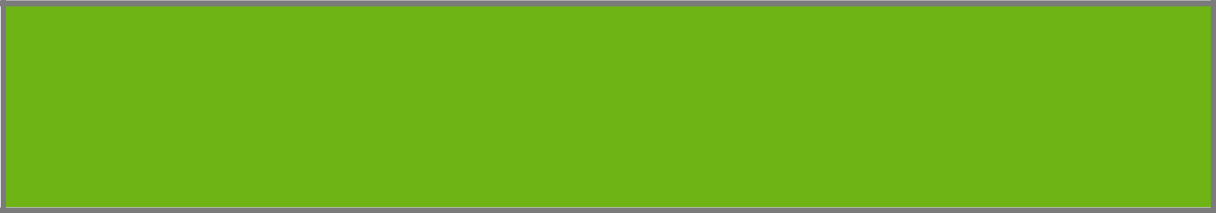**5. HTML – FORMATTING**

HTML

If you use a word processor, you must be familiar with the ability to make text bold, italicized, or underlined; these are just three of the ten options available to indicate how text can appear in HTML and XHTML.

**Bold Text**



Anything that appears within **<b>...</b>** element, is displayed in bold as shown below:

**Example**



<!DOCTYPE html>

<html>

<head>

<title>Bold Text Example</title>

</head>

<body>

<p>The following word uses a <b>bold</b> typeface.</p>

</body>

</html>

This will produce the following result:



The following word uses a **bold** typeface.

**Italic Text**



Anything that appears within **<i>...</i>** element is displayed in italicized as shown below:

**Example**



<!DOCTYPE html>

<html>

<head>

<title>Italic Text Example</title>

</head>

33



HTML



<body>

<p>The following word uses a <i>italicized</i> typeface.</p>

</body>

</html>

This will produce the following result:



The following word uses an *italicized* typeface.

**Underlined Text**



Anything that appears within **<u>...</u>** element, is displayed with underline as shown below:

**Example**



<!DOCTYPE html>

<html>

<head>

<title>Underlined Text Example</title>

</head>

<body>

<p>The following word uses a <u>underlined</u> typeface.</p>

</body>

</html>

This will produce the following result:

The following word uses an underlined typeface.

**Strike Text**



Anything that appears within **<strike>...</strike>** element is displayed with strikethrough, which is a thin line through the text as shown below:

**Example**



<!DOCTYPE html>

<html>

<head>

34



HTML



<title>Strike Text Example</title>

</head>

<body>

<p>The following word uses a <strike>strikethrough</strike> typeface.</p>

</body>

</html>

This will produce the following result:

The following word uses a ~~strikethrough~~ typeface.

**Monospaced Font**



The content of a **<tt>...</tt>** element is written in monospaced font. Most of the fonts are known as variable-width fonts because different letters are of different widths (for example, the letter 'm' is wider than the letter 'i'). In a monospaced font, however, each letter has the same width.

**Example**



<!DOCTYPE html>

<html>

<head>

<title>Monospaced Font Example</title>

</head>

<body>

<p>The following word uses a <tt>monospaced</tt> typeface.</p>

</body>

</html>

This will produce the following result:



The following word uses a monospaced typeface.

**Superscript Text**



The content of a **<sup>...</sup>** element is written in superscript; the font size used is the same size as the characters surrounding it but is displayed half a character's height above the other characters.

35



HTML

**Example**



<!DOCTYPE html>

<html>

<head>

<title>Superscript Text Example</title>

</head>

<body>

<p>The following word uses a <sup>superscript</sup> typeface.</p>

</body>

</html>

This will produce the following result:



The following word uses a superscript typeface.

**Subscript Text**



The content of a **<sub>...</sub>** element is written in subscript; the font size used is the same as the characters surrounding it, but is displayed half a character's height beneath the other characters.

**Example**



<!DOCTYPE html>

<html>

<head>

<title>Subscript Text Example</title>

</head>

<body>

<p>The following word uses a <sub>subscript</sub> typeface.</p>

</body>

</html>

This will produce the following result:

The following word uses a subscript typeface.

36



HTML

**Inserted Text**



Anything that appears within **<ins>...</ins>** element is displayed as inserted text.

**Example**



<!DOCTYPE html>

<html>

<head>

<title>Inserted Text Example</title>

</head>

<body>

<p>I want to drink <del>cola</del> <ins>wine</ins></p>

</body>

</html>

This will produce the following result:



**Deleted Text**



Anything that appears within **<del>...</del>** element, is displayed as deleted text.

**Example**



<!DOCTYPE html>

<html>

<head>

<title>Deleted Text Example</title>

</head>

<body>

<p>I want to drink <del>cola</del> <ins>wine</ins></p>

</body>

</html>

This will produce the following result:

37



HTML



**Larger Text**



The content of the **<big>...</big>** element is displayed one font size larger than the rest of the text surrounding it as shown below:

**Example**



<!DOCTYPE html>

<html>

<head>

<title>Larger Text Example</title>

</head>

<body>

<p>The following word uses a <big>big</big> typeface.</p>

</body>

</html>

This will produce the following result:



The following word uses a **big** typeface.

**Smaller Text**



The content of the **<small>...</small>** element is displayed one font size smaller than the rest of the text surrounding it as shown below:

**Example**



<!DOCTYPE html>

<html>

<head>

<title>Smaller Text Example</title>

</head>

<body>

<p>The following word uses a <small>small</small> typeface.</p>

</body>

38



HTML



</html>

This will produce the following result:



The following word uses a small typeface.

**Grouping Content**



The **<div>** and **<span>** elements allow you to group together several elements to create sections or subsections of a page.

For example, you might want to put all of the footnotes on a page within a <div> element to indicate that all of the elements within that <div> element relate to the footnotes. You might then attach a style to this <div> element so that they appear using a special set of style rules.

**Example**



<!DOCTYPE html>

<html>

<head>

<title>Div Tag Example</title>

</head>

<body>

<div id="menu" align="middle" >

<a href="/index.htm">HOME</a> |

<a href="/about/contact_us.htm">CONTACT</a> | <a href="/about/index.htm">ABOUT</a> </div>

<div id="content" align="left" bgcolor="white"> <h5>Content Articles</h5>

<p>Actual content goes here.....</p>

</div>

</body>

</html>

This will produce the following result:

39



HTML



[HOME](http://localhost/index.htm) | [CONTACT](http://localhost/about/contact_us.htm) | [ABOUT](http://localhost/about/index.htm)

CONTENT ARTICLES

Actual content goes here.....

The <span> element, on the other hand, can be used to group inline elements only. So, if you have a part of a sentence or paragraph which you want to group together, you could use the <span> element as follows

**Example**



<!DOCTYPE html>

<html>

<head>

<title>Span Tag Example</title>

</head>

<body>

<p>This is the example of <span style="color:green">span tag</span> and the <span style="color:red">div tag</span> alongwith CSS</p>

</body>

</html>

This will produce the following result:

This is the example of span tag and the div tag along with CSS

These tags are commonly used with CSS to allow you to attach a style to a section of a page.

40



**6. HTML – PHRASE TAGS**

HTML

The phrase tags have been desicolgned for specific purposes, though they are displayed in a similar way as other basic tags like **<b>, <i>, <pre>,** and **<tt>,** you have seen in previous chapter. This chapter will take you through all the important phrase tags, so let's start seeing them one by one.

**Emphasized Text**



Anything that appears within **<em>...</em>** element is displayed as emphasized text.

**Example**



<!DOCTYPE html>

<html>

<head>

<title>Emphasized Text Example</title>

</head>

<body>

<p>The following word uses a <em>emphasized</em> typeface.</p>

</body>

</html>

This will produce the following result:

The following word uses an *emphasized* typeface.

**Marked Text**



Anything that appears with-in **<mark>...</mark>** element, is displayed as marked with yellow ink.

**Example**



<!DOCTYPE html>

<html>

<head>

<title>Marked Text Example</title>

41



HTML



</head>

<body>

<p>The following word has been <mark>marked</mark> with yellow</p>

</body>

</html>

This will produce the following result:

The following word has been marked with yellow.

**Strong Text**



Anything that appears within **<strong>...</strong>** element is displayed as important text.

**Example**



<!DOCTYPE html>

<html>

<head>

<title>Strong Text Example</title>

</head>

<body>

<p>The following word uses a <strong>strong</strong> typeface.</p>

</body>

</html>

This will produce the following result:

The following word uses a **strong** typeface.

**Text Abbreviation**



You can abbreviate a text by putting it inside opening <abbr> and closing </abbr> tags. If present, the title attribute must contain this full description and nothing else.

**Example**



<!DOCTYPE html>

<html>

<head>

42



HTML



<title>Text Abbreviation</title>

</head>

<body>

<p>My best friend's name is <abbr title="Abhishek">Abhy</abbr>.</p>

</body>

</html>

This will produce the following result:

My best friend's name is Abhy.

**Acronym Element**



The **<acronym>** element allows you to indicate that the text between <acronym> and </acronym> tags is an acronym.

At present, the major browsers do not change the appearance of the content of the <acronym> element.

**Example**



<!DOCTYPE html>

<html>

<head>

<title>Acronym Example</title>

</head>

<body>

<p>This chapter covers marking up text in <acronym>XHTML</acronym>.</p>

</body>

</html>

This will produce the following result:

This chapter covers marking up text in XHTML.

**Text Direction**



The **<bdo>...</bdo>** element stands for Bi-Directional Override and it is used to override the current text direction.

43



HTML

**Example**



<!DOCTYPE html>

<html>

<head>

<title>Text Direction Example</title>

</head>

<body>

<p>This text will go left to right.</p>

<p><bdo dir="rtl">This text will go right to left.</bdo></p>

</body>

</html>

This will produce the following result:

This text will go left to right.

This text will go right to left.

**Special Terms**



The **<dfn>...</dfn>** element (or HTML Definition Element) allows you to specify that you are introducing a special term. It's usage is similar to italic words in the midst of a paragraph.

Typically, you would use the <dfn> element the first time you introduce a key term. Most recent browsers render the content of a <dfn> element in an italic font.

**Example**



<!DOCTYPE html>

<html>

<head>

<title>Special Terms Example</title>

</head>

<body>

<p>The following word is a <dfn>special</dfn> term.</p>

</body>

</html>

This will produce the following result:

44



HTML

The following word is a *special* term.

**Quoting Text**



When you want to quote a passage from another source, you should put it in between**<blockquote>...</blockquote>** tags.

Text inside a <blockquote> element is usually indented from the left and right edges of the surrounding text, and sometimes uses an italicized font.

**Example**



<!DOCTYPE html>

<html>

<head>

<title>Blockquote Example</title>

</head>

<body>

<p>The following description of XHTML is taken from the W3C Web site:</p>

<blockquote>XHTML 1.0 is the W3C's first Recommendation for XHTML, following on from earlier work on HTML 4.01, HTML 4.0, HTML 3.2 and HTML 2.0.</blockquote>

</body>

</html>

This will produce the following result:

The following description of XHTML is taken from the W3C Web site:



XHTML 1.0 is the W3C's first Recommendation for XHTML, following on from earlier work on HTML 4.01, HTML 4.0, HTML 3.2 and HTML 2.0.

**Short Quotations**



The **<q>...</q>** element is used when you want to add a double quote within a sentence.

**Example**



<!DOCTYPE html>

<html>

<head>

45



HTML



<title>Double Quote Example</title>

</head>

<body>

<p>Amit is in Spain, <q>I think I am wrong</q>.</p>

</body>

</html>

This will produce the following result:

Amit is in Spain, I think I am wrong.

**Text Citations**



If you are quoting a text, you can indicate the source placing it between an opening **<cite>**tag and closing **</cite>** tag

As you would expect in a print publication, the content of the <cite> element is rendered in italicized text by default.

**Example**



<!DOCTYPE html>

<html>

<head>

<title>Citations Example</title>

</head>

<body>

<p>This HTML tutorial is derived from <cite>W3 Standard for HTML</cite>.</p>

</body>

</html>

This will produce the following result:

This HTML tutorial is derived from *W3 Standard for HTML*.

**Computer Code**



Any programming code to appear on a Web page should be placed inside **<code>...</code>**tags. Usually the content of the <code> element is presented in a monospaced font, just like the code in most programming books.

46



HTML

**Example**



<!DOCTYPE html>

<html>

<head>

<title>Computer Code Example</title>

</head>

<body>

<p>Regular text. <code>This is code.</code> Regular text.</p>

</body>

</html>

This will produce the following result:

Regular text. This is code. Regular text.

**Keyboard Text**



When you are talking about computers, if you want to tell a reader to enter some text, you can use the **<kbd>...</kbd>** element to indicate what should be typed in, as in this example.

**Example**



<!DOCTYPE html>

<html>

<head>

<title>Keyboard Text Example</title>

</head>

<body>

<p>Regular text. <kbd>This is inside kbd element</kbd> Regular text.</p>

</body>

</html>

This will produce the following result:

Regular text. This is inside kbd element Regular text.

47



HTML

**Programming Variables**



This element is usually used in conjunction with the **<pre>** and **<code>** elements to indicate that the content of that element is a variable.

**Example**



<!DOCTYPE html>

<html>

<head>

<title>Variable Text Example</title>

</head>

<body>

<p><code>document.write("<var>user-name</var>")</code></p>

</body>

</html>

This will produce the following result:

document.write("*user-name*")

**Program Output**



The **<samp>...</samp>** element indicates sample output from a program, and script etc.

Again, it is mainly used when documenting programming or coding concepts.

**Example**



<!DOCTYPE html>

<html>

<head>

<title>Program Output Example</title>

</head>

<body>

<p>Result produced by the program is <samp>Hello World!</samp></p>

</body>

</html>

This will produce the following result:

Result produced by the program is Hello World!

48



HTML

**Address Text**



The **<address>...</address>** element is used to contain any address.

**Example**



<!DOCTYPE html>

<html>

<head>

<title>Address Example</title>

</head>

<body>

<address>388A, Road No 22, Jubilee Hills - Hyderabad</address>

</body>

</html>

This will produce the following result:

*388A, Road No 22, Jubilee Hills - Hyderabad*

49

